STANDARD OPERATING PROCEDURE
Created: Version No:

USING MOTORBIKE (2 WHEEL) TEMPLATE
Motorbikes are used for moving stock and general movement around the farm. As a rule motorbikes stay within the farm boundaries.
JOB STEPS | MEDIA | SAFETY / QUALITY / ENVIRONMENT
DO NOT use this equipment unless you have been instructed in its safe use and operation and have been given permission.  Pre-start check of two wheel motorbike  - Follow manufacturer's recommendations and warning labels  - Locate and ensure you are familiar with all controls and warnings  a. Use the TCLOC(R) (‘teeclocker’) approach to doing regular checks:  T = Tyres and wheels –  Tyre pressure: Check pressures when cold before riding. Use the low pressure gauge available from manufacturers.  Tyre tread: Check treads are adequate for task and terrain.  C = Cables and Controls - Brakes: manure is hard on brakes, check their function regularly  L = Lights and Electrical O = Oils and Fluids  C = Chassis and suspension: Foot decks are prone to damage from sticks. Check regularly and replace if damaged  Make sure your helmet is strapped onto your head. | 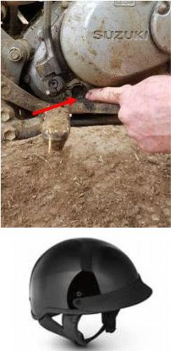 | Safety - Incorrect air pressure - the bike won’t handle properly if the air pressure is too low or too high. This affects braking and steering. Incorrect tyre pressure contributes to bike crashes.  Tyres in poor condition affects the bike’s handling and makes it harder to control on slippery or uneven surfaces.  A tyre blowout is extremely dangerous potentially causing crash and injuries.  Remove any build up of mud, dust and debris prior to checking to make it easier to identify potential problems.  Environment - Familiarise yourself with the owners manual before use of the motorbike.
After you’ve started the bike, check the following;  - Try the front and rear brakes one at a time. Make sure each brake, when applied, holds the bike.  - Make sure clutch and throttle controls work smoothly.  - Make sure you can operate hand and foot controls when you sit comfortably on the bike.  - Ensure helmet is strapped on before riding. |  | Safety - PPE - Helmet which meets Australian standards. AS-1698 and clipped on firmly,  Sturdy boots with tread. Abrasion resistant clothing to suit weather conditions I.e Weather proof jacket for wet or cold conditions.  If you have any concerns that the bike components are not functioning correctly - do not ride the bike: report the faults to senior management and document in the diary in the dairy office.

Page 1 of 2
Created: 3 March 2021 Version No: 3

USING MOTORBIKE (2 WHEEL) V3
Motorbikes are used for moving stock and general movement around the farm. As a rule motorbikes stay within the farm boundaries.
JOB STEPS | MEDIA | SAFETY / QUALITY / ENVIRONMENT
Riding 2 wheel motorbike safely;  - Ensure smooth clutch operation, gear changing and braking.  - Place feet firmly on the footrests when moving. Only put them down when you stop.  - Keep your feet horizontal on the footrests with toes pointed straight to avoid hitting the ground.  - Keep elbows away from the body for strength, and keep arms bent to act as shock absorbers.  - To help balance the bike, keep your knees against the petrol tank.  When riding on slippery ground:  - Always ride smoothly, avoiding hard braking or acceleration.  - A steady, open throttle in gear keeps the bike in more control.  - Make turns as wide as possible to keep momentum.  - When braking, use both brakes smoothly and a bit at a time, with more emphasis on the front brake.  - Brake before cornering to avoid loss of control. |  | Safety - Avoid sudden braking or steering. Look out for wires, race tapes, rocks, branches, irrigation pipes and other objects that you could run into and knock you off the bike.  Travel slowly when riding in high traffic area such as around the diary or silage stack area, be aware of other vehicle and foot traffic.  Do not carry passengers on motorbikes unless there are no practical alternatives, they must also wear a helmet.  Quality - Active riding uses balance and body position to influence stability and performance when cornering and riding on a slope.  Keep your feet horizontal on the footrests to keep the bike stable. Taking one foot off the footrest will unbalance the bike. This can make the bike slide or fall. Balancing on the footrests improves all parts of riding and is an essential part of good riding technique.  Environment - The common causes of motorbike accidents are;  - not riding to the conditions  - not paying attention to the terrain  - inexperience  - showing off
Motorbike shut down and parking;  - Park on even flat ground  - Ensure stand can hold the weight of the bike before dismounting.  - If parking the bike for a short period of time, ensure the bike is not in the thoroughfare of surrounding traffic or movement on farm  - Before returning motorbike to shed after use, refuel for next user.  - Wash bike down if heavily soiled with mud  - Report any concerns or mechanical failures to senior management and document in the diary in the diary office. | 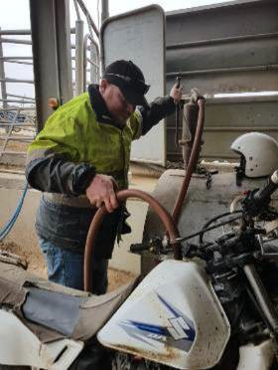 | Safety - Let the motorbike cool off before refueling  When refueling the motorbike do not leave it untended.  Do not smoke while refuelling motorbike.  Do not leave bikes in the blind spot of larger machinery in the area.  Environment - Do not ride motorbike on public roads if you do not have a motorbike licence and/or if the bike is not registered.
Created: 3 March 2021 Version No: 1

Page 2 of 2

