STANDARD OPERATING PROCEDURE
Created:________ Version No:____

USE OF NEEDLES AND INJECTING CATTLE TEMPLATE
The practice of injecting animals on farm has food safety considerations, human safety risks and animal health and welfare risks and benefits. All injections of animal health treatments should be carried out as part of a complete health program on the farm and with the guidance of a veterinarian who is experienced in cattle health. You will need to edit this template to suit your farm business needs.
JOB STEPS | MEDIA | SAFETY / QUALITY / ENVIRONMENT
Ensure the animal is restrained securely to minimise animal movement and allow safe access of the person administering the injection.  This may involve the use of a crush, headbail or race with sufficient animals to prevent excess movement or in the case of a down cow a halter or nose pliers. | 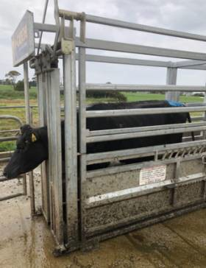 | Safety - Operator safety is essential to prevent injury and accidental injection. Gloves should be worn for spill protection. Prevent movement of animal.  Do not place hands and arms in between rails or in areas where they can become caught or crushed.  It is essential to keep the hand not being used on the injection device well away from the needle to ensure self-injection does not occur.  Animal restraint is also essential to prevent injury to the animal during the injection process.  Quality - Adequate restraint will ensure the entire dose is injected into the animal in the correct manor and minimise the chance of needle breakage.

USE OF NEEDLES AND INJECTING CATTLE
The practice of injecting animals on farm has food safety considerations, human safety risks and animal health and welfare risks and benefits. All injections of animal health treatments should be carried out as part of a complete health program on the farm and with the guidance of a veterinarian who is experienced in cattle health. You will need to edit this template to suit your farm business needs.
JOB STEPS | MEDIA | SAFETY / QUALITY / ENVIRONMENT
Always follow label directions. This is to ensure the product is registered for use in dairy cattle, appropriate withholding periods can be observed, to determine the dose rate and treatment regime. The label will also determine site and volume of product to be injected.  This will inform the method of administration (e.g. size of syringe, ability to use multidose guns). The site of administration (i.e. intramuscular, intravenous or subcutaneous) and the type of needle to be used.  If products are not used according to the label directions there is potential for residue violations, the product to not work as expected, underdosing and reactions.  You must have written advice from your veterinarian (including any variation to withholding periods) before any off-label usage of products. | 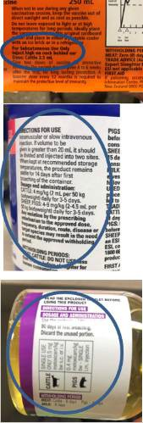 | Safety - Food safety is of paramount importance when administering treatments to animals.  Following the label directions ensures that food safety will not be compromised.  Quality - Optimising animal health and ensuring withholding periods are met ensures quality milk and meat products are provided to consumers.  Correct dosage at the correct site ensures animal health requirements are achieved.
Created: 11 April 2021 Version No: 1

USE OF NEEDLES AND INJECTING CATTLE
The practice of injecting animals on farm has food safety considerations, human safety risks and animal health and welfare risks and benefits. All injections of animal health treatments should be carried out as part of a complete health program on the farm and with the guidance of a veterinarian who is experienced in cattle health. You will need to edit this template to suit your farm business needs.
JOB STEPS | MEDIA | SAFETY / QUALITY / ENVIRONMENT
Select the correct size of needle.  If an intramuscular injection is required in adult cattle, the needle should be at least 1.5 inches (32mm) long to ensure the product is injected into the correct site. In calves this can be reduced to 1” (25mm).  Subcutaneous injections (e.g. vaccinations) require shorter needles to ensure the dose is injected between the skin and muscle layers.  The higher the gauge the finer the needle. Thick solutions require a lower gauge needle, but it should be remembered that this will be more painful and harder to inject in the cow. For single use needles, always use a new needle for each animal. For multi-use needles, change needle regularly to ensure that they are sharp and to minimise risk of infections. | 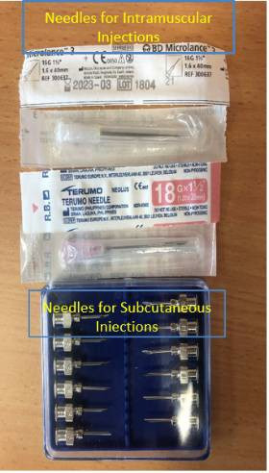 | Safety - Using the correct needle ensures the dose can be administered quickly, at the correct site for action and with less pain to the animal.Food safety is of paramount importance when administering injections to animals. Using the correct size and sharp needles helps prevent needle breakage and reduces risk of infection at the injection site.  Correct dosage ensures that registered withholding periods can be followed to ensure food safety.  Quality - The use of blunt or contaminated needles may increase the risk of infection and result in carcasse damage.
Select the correct site of injection according to the label directions.  Intramuscular injections should always be given in the neck wherever possible to avoid carcass damage.  The rump or leg muscles should only ever be used when the neck cannot be safely used.  Subcutaneous injections should also always be given in the neck wherever possible to avoid carcass damage.  Some subcutaneous injections may be given over the ribs.  Intravenous injections should be given in the jugular vein. The milk vein should be avoided due to the high risk of infection. | 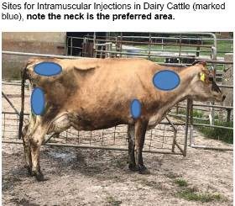 | Safety - Intramuscular and subcutaneous injections should always be given in the neck if it is safe to do so (see comments in Section 1 above).  Quality - Intramuscular and subcutaneous injections should always be given in the neck to avoid carcass damage.
Created: 11 April 2021 Version No: 1

USE OF NEEDLES AND INJECTING CATTLE
The practice of injecting animals on farm has food safety considerations, human safety risks and animal health and welfare risks and benefits. All injections of animal health treatments should be carried out as part of a complete health program on the farm and with the guidance of a veterinarian who is experienced in cattle health. You will need to edit this template to suit your farm business needs.
JOB STEPS | MEDIA | SAFETY / QUALITY / ENVIRONMENT
Sites for Intramuscular Injections in Dairy Cattle (marked blue)  see step 4 for sites | 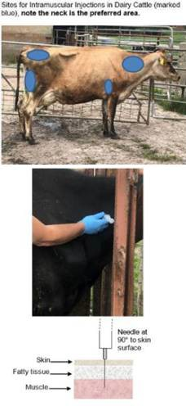 | Safety - Intramuscular and subcutaneous injections should always be given in the neck if it is safe to do so (see comments in Section 1 above).  Quality - Intramuscular and subcutaneous injections should always be given in the neck to avoid carcass damage.
Created: 11 April 2021 Version No: 1

USE OF NEEDLES AND INJECTING CATTLE
The practice of injecting animals on farm has food safety considerations, human safety risks and animal health and welfare risks and benefits. All injections of animal health treatments should be carried out as part of a complete health program on the farm and with the guidance of a veterinarian who is experienced in cattle health. You will need to edit this template to suit your farm business needs.
JOB STEPS | MEDIA | SAFETY / QUALITY / ENVIRONMENT
Sites for subcutaneous injections in dairy cattle (marked red). | 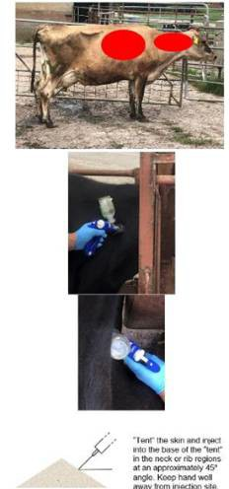 | Safety - Intramuscular and subcutaneous injections should always be given in the neck if it is safe to do so (see comments in Section 1 above).  Quality - - Intramuscular and subcutaneous injections should always be given in the neck to avoid carcass damage.
Created: 11 April 2021 Version No: 1

USE OF NEEDLES AND INJECTING CATTLE
The practice of injecting animals on farm has food safety considerations, human safety risks and animal health and welfare risks and benefits. All injections of animal health treatments should be carried out as part of a complete health program on the farm and with the guidance of a veterinarian who is experienced in cattle health. You will need to edit this template to suit your farm business needs.
JOB STEPS | MEDIA | SAFETY / QUALITY / ENVIRONMENT
Site for intravenous injections in dairy cattle (marked yellow) | 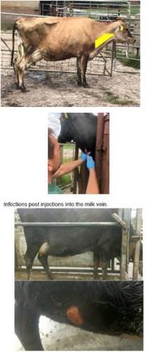 | Quality - Intravenous injections should only be given by trained, competent operators.
Ensure the site of injection is clean.  Dirty injection sites may cause infections or site abscesses to develop. If the site of injection is particularly dirty it should be cleaned with an appropriate antiseptic and dried to minimise |  | Quality - Clean injection sites prevent infection and carcasss damage.
Created: 11 April 2021 Version No: 1

