STANDARD OPERATING PROCEDURE
Created: Version No:

SILAGE STACK UNCOVERING TEMPLATE
Once silage stacks have completed their set fermentation time they are able to be fed out. Staff involved in feeding out silage must follow the set out procedure below when opening and removing silage from the stack. Silage stack areas once a stack has an open face there it becomes a high risk area as the face has the potential of fall from height or to collapse causing serious injury or a potential fatality. Edit this template to suit your farm.
JOB STEPS | MEDIA | SAFETY / QUALITY / ENVIRONMENT
Danger zone guide for the face of a silage stack.  Silage stack faces have to potential to collapse due to changes in compaction as silage is removed and overhangs are created when removing silage from the lower section of the stack.  Observe area close to the face of the stack for signs of cracks or overhangs and remain clear of the area while working.  Wherever possible keep a distance of three times the height of the silage stack away from the base of the face when on foot.  The silage stack area is a high traffic environment when operating the loader or other vehicles. The driver must be aware of any people on foot when silage stack tyres and covers are being removed.  Staff should not work alone within this danger zone when they are the only person in site. A second staff member must be in the immediate area as an observer. | 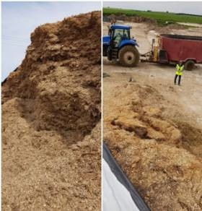 | Safety - Never allow unauthorised people to approach the feedout face of the silage stack on foot.  A rule-of-thumb is never stand closer to the silage face than three times its height.  Always assess the face of the stack for overhangs, cracks or weak points before attempting to climb the stack to remove tyres.  Never “dig” the bucket into the bottom of the silage. Undercutting creates an overhang of silage that can loosen and collapse/tumble to the ground.  When sampling silage, take samples from a front-end loader bucket after it is moved to a safe distance from the feedout face.  This is a situation that is common when the unloader bucket cannot reach the top of the stack.  Quality - Poorly packed layers can lead to areas of weakness that enhance the likelihood of an avalanche occurring during feedout.  Environment - Never drive the unloader parallel to and in close proximity of the feedout face of the stack. Avoid being complacent. Always pay attention to your surroundings and never think that a collapse cannot happen.

Page 1 of 3
TEMPLATE: 23 August 2020 Version No: 1

SILAGE STACK UNCOVERING V1
Once silage stacks have completed their set fermentation time they are able to be fed out. Staff involved in feeding out silage must follow the set out procedure below when opening and removing silage from the stack. Silage stack areas once a stack has an open face there it becomes a high risk area as the face has the potential of fall from height or to collapse causing serious injury or a potential fatality. Edit this template to suit your farm.
JOB STEPS | MEDIA | SAFETY / QUALITY / ENVIRONMENT
Removing tyres from the face of the stack;  Removing tyres from the top of the stack face to expose silage depends on predicted weather conditions.  Only expose enough of the face to cover 48 hours of feeding out silage material.  Have a second staff members to assist in removing tyres from the face of the stack - usually after milking  Using the loader place the bucket against the face of the stack at the height where the tyres need to be removed.  Throw tyres into the bucket working from the tyres closest to the face then back, exposing 3-4 metres of plastic.  Once the bucket is full dump tyres in allocated area for reuse. Once load is dumped reposition. the loader in the next area of the face of the stack where tyres need to be removed at the face of the stack. Tyres in the lower section of the stack can be rolled off the stack | 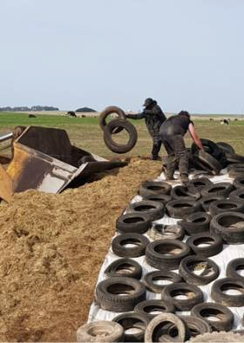 | Safety - PPE - Sturdy boot with non slip soles, High Vis jacket/vest or shirt.  Have two staff members present in case of collapse of silage face occurs when removing tyres.  Always stay at least 1.5 metres back from the face of the silage stack when removing tyres from the top of the stack  Always work from the far side of the tyres from the face of the stack when picking them up to remove.  When throwing tyres be mindful of of manual handling techniques including;  - never twist from the waist always move your feet to turn  - Bend at the knees and keep your back straight when lifting tyres  - Lift tyres in both hands to maintain balance and spread the load when lifting.  - Only lift what you are capable of when removing tyres.  - Stop working and report any discomfort immediately so the risk can be managed before injury occurs.  Only pick up tyres that have fallen down the face of the stack when the loader is well clear of the face and you have communicated with the driver what you are doing.  Never allow people to stand near the feed out face, and a rule of thumb is never stand closer to the feeding face than three times its height.  Quality - Only expose the required amount of silage for the next 24-48 hrs feeding as quality of silage will drop off once exposed to air and sunlight.
Created: 23 August 2020 Version No: 1

SILAGE STACK UNCOVERING V1
Once silage stacks have completed their set fermentation time they are able to be fed out. Staff involved in feeding out silage must follow the set out procedure below when opening and removing silage from the stack. Silage stack areas once a stack has an open face there it becomes a high risk area as the face has the potential of fall from height or to collapse causing serious injury or a potential fatality. Edit this template to suit your farm.
JOB STEPS | MEDIA | SAFETY / QUALITY / ENVIRONMENT
Pulling back plastic from the face of the stack.  Working together pull the plastic back - walking it away from the face of the stack to expose the 3-4 metres of silage.  Weigh down the plastic pulled back from the face with tyres.  Once exposing the required amount of silage stack ensure there are no tyres at the bottom of the face of the stack or in immediately surrounding thoroughfares. Collect all tyres in these areas and return them to the dump/storage site. |  | Safety - Falls from heights;  Working on top of the silage stack creates a risk for falls. Workers can easily slip on plastic when covering or uncovering a bunker or pile, especially in wet or windy weather conditions.  Use caution when removing tyres and plastic during wet or windy conditions which can cause the plastic to become slippery and difficult to hold and control.  Communicate with other members of staff when pulling plastic back to spread the workload  Continually observe the area being uncovered for signs of rotting or cracks as these are the early warning signs of potential silage face collapse.  Only approach the base of the face of the stack to collect tyres when the loader/tractor FEL has left the immediate area. Communicate with driver so they are aware of your movements
Created: 23 August 2020 Version No: 1

